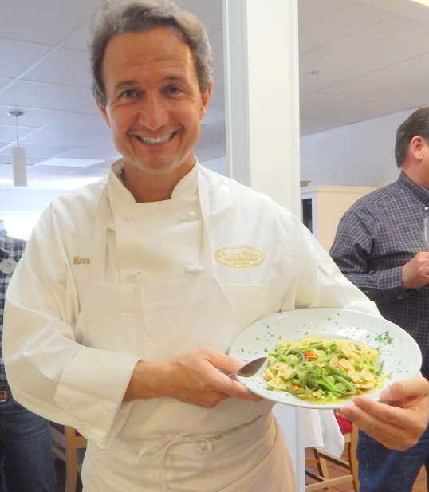

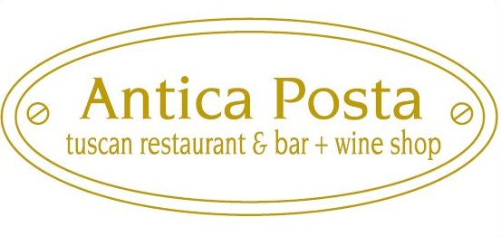

Marco during a cooking class
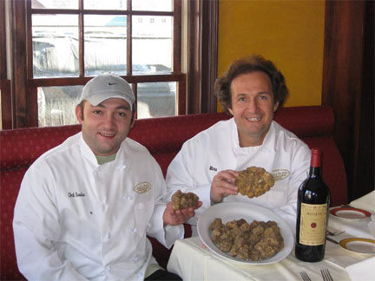
Marco and Sandro Betti proudly invite you to taste the simple, flavorful dishes that have made Italian and Tuscan cooking the most appreciated cuisine in the world.

Antica Posta of Buckhead brings to our community the same genuine and sincere cuisine of Tuscany.

You will enjoy the delicate blend
of meats, fish, vegetables, spices,
and condiments that for centuries
have pleased the palate of the
Marco and Sandro with White Truffles most demanding Florentines.
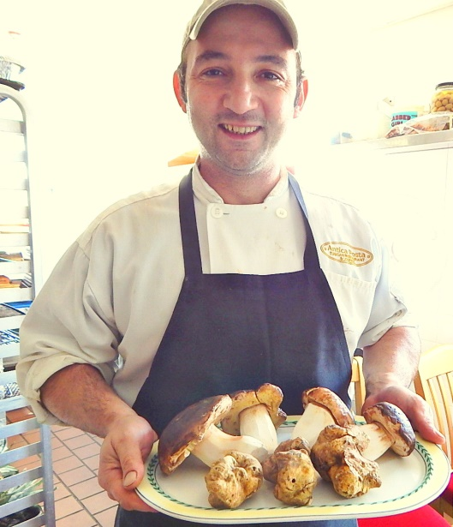

Welcome to the first authentic
Tuscan Restaurant
in Georgia.

519 East Paces Ferry Rd NE, Atlanta GA 30305
404-262-7112
marco@anticaposta.com

Open every day at 5 pm

Sandro with Porcini Mushroom

Our Signature Antipasti – Appetizers

Bruschette con pomodori freschi e basilico $ 10 (Vegan)
Bruschetta with fresh tomatoes, basil, evoo

Insalata di Marco $ 13 * (Vegan)
Owners favorite Salad: Arugula, green cabbage, cherry tomatoes, olives, capers, green beans, cucumbers, evoo & whole grain mustard

Insalata con rucola e Parmigiano Reggiano $ 14 * (Vegetarian)
Salad with arugula lettuce, Parmigiano Reggiano cheese, and evoo dressing

Caprese: mozzarella di bufala, pomodori rucola olio ev Toscano $ 14 *(Vegetarian)
Caprese salad: Italian buffalo milk mozzarella, flown from Italy, vine ripe tomatoes, arugula, evoo dressing

Spaghetti al pomodoro $ 16 Appetizer (Vegan)
Spaghetti with Tuscan tomato sauce

Carpaccio di manzo $ 18 *
Piedmontese Beef Carpaccio on a bed of arugula topped with shaved Parmigiano cheese

Burrata di bufala con pachini e balsamico $ 15 *
Burrata cheese made with Italian buffalo milk, cherry tomatoes, balsamic reduction

Salmone affumicato alla Toscana con insalata di rucola e cetrioli $ 18 *
Tuscan spices flavored Smoked Salmon atop arugula, cucumber and capers salad

Zuppa di fagioli cannellini e gamberi $ 18 *
Cannellini beans soup with Red shrimp and truffle oil

Prosciutto San Daniele e mozzarella di bufala $ 18 *
San Daniele prosciutto and fresh buffalo milk mozzarella from Italy

Polpo alla griglia, insalata di rucola, cipolle e Pachini $ 19 *
Antica’s Grilled Octopus: The Best Octopus recipe in the World

Cappesante alla piastra con burro tartufato $ 19 *
Skillet seared Scallops with black truffle butter

Foie Gras Con salsa al Vin Santo $ 19
Pan Seared Hudson Valley Foie Gras with Vin Santo reduction

Antipasto misto: Pecorino, Parmigiano, Prosciutto, Finocchiona e Olive $ 29 *
Platter of Pecorino, Parmigiano, Prosciutto, Salami & Olives (Serves 2)

Any of the above items followed by * are Gluten Free

Consuming Raw or Undercooked Meats, Poultry, Seafood, Shellfish or Eggs May Increase your risk of foodborne illness, especially if you have certain medical conditions.

We are here to please you and appreciate your business!
Please note due to the high cost of ingredients all food and beverage menu items sales are final.
Our Family Recipes cannot be changed. Thank you for your understanding.
Use of loud volume electronic devices (iPads, tablets, cell phones etc...) is not allowed in the premises at any time
A 20% SERVICE CHARGE WILL BE ADDED TO PARTIES OF 8 AND MORE

Our Signature Primi Piatti

We serve our pastas with plenty of sauce, so you can dig in like a naughty kid

Tortellini alla panna $ 25 Main Course ONLY
Veal Tortellini with fresh cream sauce & Parmigiano cheese

Rigatoni al ragù di salsicce di maiale $ 25 Main Course ONLY
Rigatoni with pork sausage ragù

Rigatoni all’arrabbiata $ 23 Main Course ONLY (Marco’s Favorite Pasta)
Rigatoni with classic Arrabbiata spicy tomato sauce (vegetarian & vegan)

Spaghetti Primavera $ 26 Main Course ONLY (vegan)
Spaghetti with asparagus, broccoli, green beans, olives in a Tuscan tomato sauce

Ravioli alla Pomarola di Mamma Rosanna $ 24 Main Course ONLY
Spinach and Ricotta Ravioli with Mamma Rosanna Betti Tuscan tomato sauce

Ravioli al ragù toscano $ 19 Appetizer - $ 27 Main Course
Spinach and Ricotta Ravioli with classic mild flavor Tuscan meat sauce (beef and veal)

Pappardelle al ragù di cinghiale alla toscana $ 28 Main Course ONLY
Pappardelle with Tuscan style Wild Boar ragù

Ravioli burro e salvia $ 19 Appetizer - $ 28 Main Course
Spinach and ricotta cheese ravioli with butter and sage

Penne con Gamberi Fra’ Diavola $ 19 Appetizer - $ 29 Main Course
Penne with spicy tomato sauce & shrimp

Gnocchi con Pomodoro e mozzarella $ 21 Appetizer - $ 31 Main Course
House made Gnocchi with Tuscan sauce and Mozzarella

Taglierini alla panna tartufata $ 21 Appetizer - $ 31 Main Course
House made Taglierini pasta with creamy truffle sauce

Risotto con gamberi, cozze, cappesante e zucchine * $ 26 Appetizer - $ 36 Main
Risotto with Fresh Shrimp, Mussels, Scallops and Zucchini

Linguine allo scoglio con aragosta, gamberi e cappesante $ 40 Main Course ONLY
Linguine pasta with fresh Maine Lobster, Shrimp and Scallops sautéed with shallots, parsley
in an evoo white wine sauce

Penne, Farfalle, Gemelli, Rigatoni, Spaghetti, Linguine can be Vegan served with Tuscan Tomato Sauce
Our house made Fresh Pastas (Pappardelle, Ravioli, Tortellini, Gnocchi) contains small quantity of eggs
Any of the above sauces can be made with gluten free Penne pasta
The Truth About Pasta…..Fresh Pasta IS NOT better than Dry Pasta: Just Different
Traditional Italian Pasta Recipes Chart
Pasta with Seafood and Spicy Sauces: 100% Dry Pasta
Pasta with Cream & Butter Sauces: 70% Fresh Pasta 30% Dry Pasta
Pasta with Meat Sauces: 80% Fresh Pasta 20% Dry Pasta
Pasta with Tomato Sauce: 50% Fresh Pasta 50% Dry Pasta

Our Signature Secondi Piatti (Main Courses)

Chef Sandro Oven Roasted Tuscan Chicken $ 28 *
The Betti Family Oven Roasted Chicken Recipe at its best. Free range chicken marinated with evoo and Tuscan herbs. Best roasted chicken you could ever eat

Salmone alla Livornese $ 30 *
Salmon sautéed with cherry tomatoes, olives & capers

Petto di pollo arrosto piccante $ 30 *
Flash roasted free range light spicy double chicken breast, fresh veggie mix garnish

Tonno alla griglia con tartufata di nero estivo $ 42 *
Tuna steak, grilled to liking, topped with black truffle sauce, fresh veggie mix garnish

Carrè d’agnello al forno alla Toscana $ 40 *
Tuscan Oven Roasted Rack of Lamb seasoned with Sage & Rosemary

Filetto di spigola del Pacifico al forno con verdure $ 42 *
Oven roasted filet of Chilean Sea Bass, fresh veggie mix garnish

Filetto di manzo alla griglia $ Market *
Prime Beef 8 oz. grilled Center Cut Filet

Tagliata di manzo Piedmontese alla griglia con rucola $ Market *
Grilled Piedmontese Ribeye 14 oz Steak, sliced atop arugula lettuce

Lombatina di Vitella all griglia $ 48 *
Best Veal Chop in the City 14 oz Chop, perfectly trimmed and grilled

Ossobuco alla toscana $ 48 *
Centre cut 3” Veal shank braised in the traditional Tuscan way

Tartufo Nero $ 14 *
Add Black Truffle (thin slices cured in evoo) to any of the dishes above

Swordfish and Mediterranean Branzino Specials

Only offered when we get top quality Swordfish and Mediterranean Branzino. Ask your server if it is available

Branzino del Mediterraneo al forno (leggermente piccante) con capperi $ 49 *
Mediterranean Branzino (whole fish 700 grams) oven roasted, lightly spicy, topped with capers

Pesce spada alla griglia con salsa di olive e capperi $ 39 *
Grilled Swordfish, with Italian olives & capers sauce (on the side)

Book your next dinner party in one of our Private Dining Rooms

We are here to please you and appreciate your business!
Please note due to the high cost of ingredients all food and beverage menu items sales are final.
Our Family Recipes cannot be changed. Thank you for your understanding.
Use of loud volume electronic devices (iPads, tablets, cell phones etc...) is not allowed in the premises at any time
A 20% SERVICE CHARGE WILL BE ADDED TO PARTIES OF 8 AND MORE

Contorni – Sides (All Vegan)

Broccoli Saltati Broccoli sautéed with Tuscan evoo and Vidalia onions $ 12 *

Verdure miste saltate Seasonal Veggie sautéed with Tuscan evoo and Vidalia onions $ 12 *

Patate al forno con salvia e rosmarino $ 9 * Oven roasted sage & rosemary potatoes

Insalata con rucola e misto campo, olio e.v. toscano e balsamico $ 9 * v
Salad with arugula and mixed field greens, Tuscan evoo & aged balsamic

Asparagi al vapore con evoo toscano $ 13 * Steamed asparagus with Tuscan evoo

Spinaci saltati con olio ev e cipolle Vidalia $ 13 *Spinach, sautéed with evoo and Vidalia onions

Lenticchie Italiane in umido $ 12 *Braised organic Italian Lentils

EXTRAS

Lobster sauteed, white wine evoo sauce $ 29

Pomarola Tuscan Tomato Sauce $ 14

Alfredo Sauce $ 16

Broccoli (added to pasta sauces) $ 10

Spinach (added to pasta sauces) $ 10

Grilled Chicken Breast $ 15

Shrimp in a white wine evoo sauce $ 19

Grilled Salmon Filet $ 22

Dolci, frutta e formaggi

Gelato alla Mandorla $ 8 *
Antica’s famous Almond gelato

Mousse al cioccolato $ 8 *
Chocolate mousse

Fragole con panna $ 8 *
Strawberries with house made whipped cream

Panna cotta con salsa ai frutti di bosco $ 8 *
Fresh cream pudding with wild berry sauce

Torta della Nonna $ 8
The delicious Florentine grandmother’s cake stuffed with custard cream.

Cannoli con crema pasticcera $ 8
Cannoli stuffed with house made Tuscan Pasticcera cream

Torta del Nonno $ 8
The delicious Florentine grandpa’s cake stuffed with chocolate cream

Semifreddo al torrone $ 8 *
Nougat Ice Cream cake

Parmigiano Reggiano $ 9 *
Parmigiano Reggiano: simply the best Italian cheese

Pecorino Toscano $ 9 *
Pecorino: the traditional sheep’s milk cheese from Tuscany

Espresso $ 4 Cappuccino $ 5

Book your next dinner party in one of our Private Dining Rooms
Use of loud volume electronic devices (iPads, tablets, cell phones etc...) is not allowed in the premises at any time

Vegan & Vegetarian

Our Signature Antipasti – Appetizers

Bruschette con pomodori freschi e basilico $ 10 (Vegan)
Bruschetta with fresh tomatoes, basil, and extra virgin olive oil

Insalata di Marco $ 13 * (Vegan)
Owners favorite Salad: Arugula, green cabbage, cherry tomatoes, olives, capers, green beans, cucumbers, evoo & whole grain mustard

Insalata con rucola e Parmigiano Reggiano $ 14 * (Vegetarian)
Salad with arugula lettuce, Parmigiano Reggiano cheese, and evoo dressing

Caprese: mozzarella di bufala, pomodori rucola olio ev Toscano $ 14 *(Vegetarian)
Caprese salad: Italian buffalo milk mozzarella, flown from Italy, vine ripe tomatoes, arugula, evoo dressing

Spaghetti al pomodoro $ 16 Appetizer (Vegan)
Spaghetti with Tuscan tomato sauce

Our Signature Primi Piatti

Risotto agli asparagi $ 28 Main Course ONLY
Risotto with asparagus (Vegan)

Rigatoni all’arrabbiata $ 23 Main Course ONLY (Marco’s Favorite Pasta)
Rigatoni with classic Arrabbiata spicy tomato sauce (Vegan)

Ravioli alla Pomarola di Mamma Rosanna $ 23 Main Course ONLY (Vegetarian)
Spinach and Ricotta Ravioli with Mamma Rosanna Betti Tuscan tomato sauce

Gnocchi alla Pomarola di Mamma Rosanna $ 28 Main Course ONLY (Vegan)
Spinach and Ricotta Ravioli with Mamma Rosanna Betti Tuscan tomato sauce

Gnocchi con Pomodoro e mozzarella $ 21 Appetizer - $ 31 Main Course (Vegetarian)
House made Gnocchi with Tuscan sauce and Mozzarella

Taglierini alla panna tartufata $ 21 Appetizer - $ 31 Main Course (Vegetarian)
House made Taglierini pasta with creamy truffle sauce

Contorni – Side dishes (all vegan)

Broccoli Saltati Broccoli sautéed with Tuscan evoo and Vidalia onions $ 12 *

Verdure miste saltate Sauteed mixed Seasonal Veggie $ 12 *

Patate al forno con salvia e rosmarino $ 8 * Oven roasted sage & rosemary potatoes

Insalata con rucola e misto campo, olio e.v. toscano e balsamico $ 8 *
Salad with mixed field greens, Tuscan evoo & aged balsamic

Asparagi al vapore con evoo toscano $ 13 * Steamed asparagus with Tuscan evoo

Spinaci saltati con olio ev toscano e cipolle vidalia $ 13 *
Spinach, sautéed with Tuscan evoo and Vidalia onions

We are here to please you and appreciate your business!
Please note due to the high cost of ingredients all food and beverage menu items sales are final.
Our Family Recipes cannot be changed. Thank you for your understanding.
Use of loud volume electronic devices (iPads, tablets, cell phones etc...) is not allowed in the premises at any time
A 20% SERVICE CHARGE WILL BE ADDED TO PARTIES OF 8 AND MORE

Italian Mineral Water

Panna Still 1 liter glass bottle $ 5 San Pellegrino Sparkling 1 liter glass bottle $ 5

Mexican Mineral Water

Topo Chico Sparkling 0.750 liter glass bottle $ 6

